Rocoo DiVerdi
Manik Singh Sethi
Interactive Programming – Theremin

Project Overview – We have tried to create a Theremin device that tracks a purple ball and then determines the location of the ball on the screen in two axes. The horizontal axis is then used to change the frequency of the output sound and the vertical axis corresponds to volume of the output sound. We used different modules like OpenCV and Nsound to create the project in two parts – a video tracking part and an audio output part.

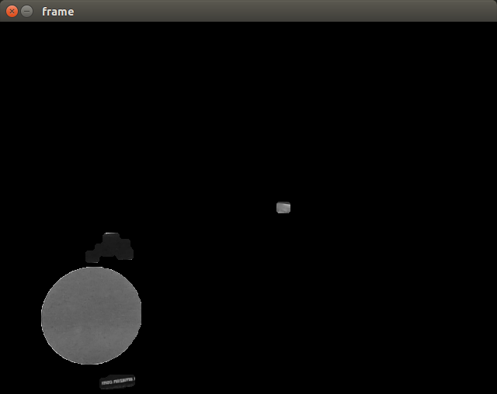
Results: The final result is a functioning Theremin like device that responds to the user's use of placement of a purple ball. The output sound increases in frequency(pitch) as the ball moves to the right (as long as it is in view of the web cam) and increases in volume as the ball moves up in view of the web cam. This was the intended functionality of the program. The ball is clearly tracked by the web cam based on the color purple and then the output is changed in real time until the program is quit. It is possible to create interesting musical outputs if the user tries various experiments with the ball, like juggling three simultaneously because there is movement is the x axis and the y axis.

The best way to really see the results is to actually try the program and hear the Theremin program in use. The image above shows the screen the user will see when the program is active. The Circle on the bottom is an example of a purple circle image found on the Internet. This shows that there is not much interference from the surroundings but some small amount of shading and purples should be expected to show up without compromising the performance greatly. When the program is running, the sound clip is continuously restarted, so there is no continuous hum of the tone, rather, the sound keeps playing one file after the other but the real time reaction of the program is not compromised.
_________ ________
| Ball | | Note |
|________| |_______|

Implementation: There is no inheritance in the project so there is no interesting UML diagram. However, there are two classes that can be explained a little more closely. Most importantly for ball tracking, there is a ball object which has an image frame, color limitations, an x position and a y position. The second object in the program is a note class that maintains the playback and usage of sound output. That object has a pitch, and a volume specifically. The controller would be the manipulations of the ball by the user model would be considered to be the positions of the ball(s) in the system, the view would be the output sound. The reason a purple ball is chosen is to simplify the object tracking system to just look for the color purple (chosen arbitrarily) and the circle shape of a ball makes it simpler to find the central position. Another major decision taken was to create files of the different tones beforehand and only access those from the program, played at specified volumes. This is to save time. In the original case, the program would write the sound file and then play it every time it received input.
We made one program which only has to be run once on a any computer to create the required sound files. This program relies on Nsound to save a separate file for each note in a blues scale (for 19 notes), numbered sequentially with 2 digit integers. The volume of these saved files is our maximum volume because the system volume settings used later can multiply the volume by numbers between 0 and 1.
For object tracking, we first isolated the color purple. That was done using OpenCV tools, starting with inRange to filter out all colors not in the purple range. The result was cleaned up using a combination of eroding, dilating, and blurring the image. Then, the center of the shape needs to be found. Previously, the program would loop through all of the pixles in the frame and find the average location of all white pixels. This method caused significant lag, so we switched to Hough Circles to find all the circles that fit within the purple shape. We then used a weighted average based on the radius of the circle to find the center of the object efficiently. That position is then given to the note object which uses the x position to call a file containing a corresponding pitch and uses the y position to adjust the systems volume output. The sound work is mainly powered by Pygame.

Reflection: In the barebones of the project, it was quite manageable but the usability and sensitivities of using video and audio manipulations created difficulties for both partners of the project so it was well suited for the both of us. We had deemed success as a system that could take in user input based on video and output varied pitch and volume. This was achieved through much work and integration of efforts. Until we both did the OpenCV and sound toolboxes, it was hard to head forward but both provided great bases for customization and specialization. Specifically for the audio portion, it was quite difficult to get a start because there are so many packages for making and playing audio but finding one best for this application was not clear until the toolox was completed. The approach to pair programming we took was interesting, with Rocco taking on the video manipulation and Manik taking on the audio portion. Toward the very end of the project, the two components were put together. However, throughout the process, we both conferred on progress and what we were learning and how the model could be adjusted to reflect those changes. That seemed to be a useful aspect of our teamwork.
We did not get to achieve our stretch goals, which were to graph out the data inputs over a single run of the program and to track a hand instead of a simple object. We learned about the patients and nuances that can often change the effectiveness of a program that depends entirely on video and audio inputs/outputs. Next time, it may be better to get more time together and work simultaneously on single parts. Still, division of labor was useful for us.

